Figure 1 Figure 2
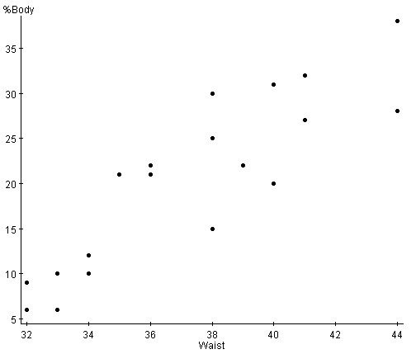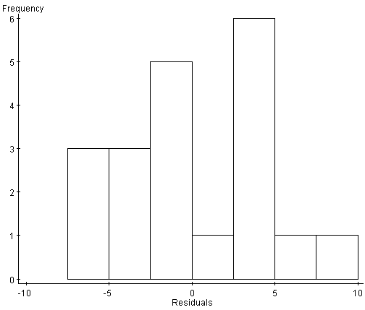

Figure 3 Figure 4
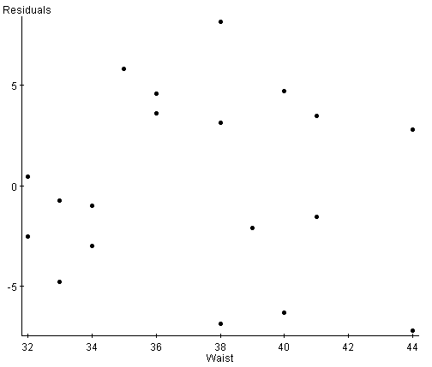 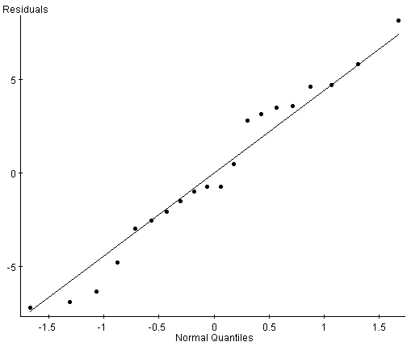\

Regression Example: Measuring body fat can be tedious and expensive. The “standard reference” measurement is by dual-energy X-ray absorptiometry (DXEA), which involves two low dose X-ray generators and takes 10 to 20 minutes. How close can we get to a useable prediction of body fat from easily measurable variables such as height, weight, or waist size?

Simple Linear Regression Output
Simple linear regression results:
Dependent Variable: %Body
Independent Variable: Waist
Sample size: 20
R (correlation coefficient) =
R-sq =
Estimate of error standard deviation: 4.5397
Parameter estimates:
Parameter | Estimate | Std. Err. | DF | T-Stat | P-Value
Intercept | -62.55732 | 10.157673 | 18 | -6.1586275 | <0.0001
Slope | 2.2215202 | 0.27278873 | 18 | 8.143738 | <0.0001
Analysis of variance table for regression model:
Source | DF | SS | MS | F-stat | P-value
Model | 1 | 1366.7903 | 1366.7903 | 66.32047 | <0.0001
Error | 18 | 370.95975 | 20.608875
Total | 19 | 1737.75

1. What four conditions should you check to determine if fitting a linear model is
appropriate for this data set? Check these conditions/

a)

b)

c)

d)
2. Write the least squares equation for the data. Use variable names.

3. Interpret the meaning of the slope value in the context of the question.

4. Use your equation to predict the body fat% on a person with a waist size of 38in.

5. What is the value of the correlation coefficient? Interpret its meaning in context.

6. Explain what the r² value means in this example.

7. Test the null hypothesis of no relationship against the directional alternative that the
percentage of body fat increases with waist size. Let α = .10

8. Construct a 95% confidence interval for the slope of the regression.

9. What is the relationship between the F-statistic in the ANOVA table and the t-value for the slope coefficient?

